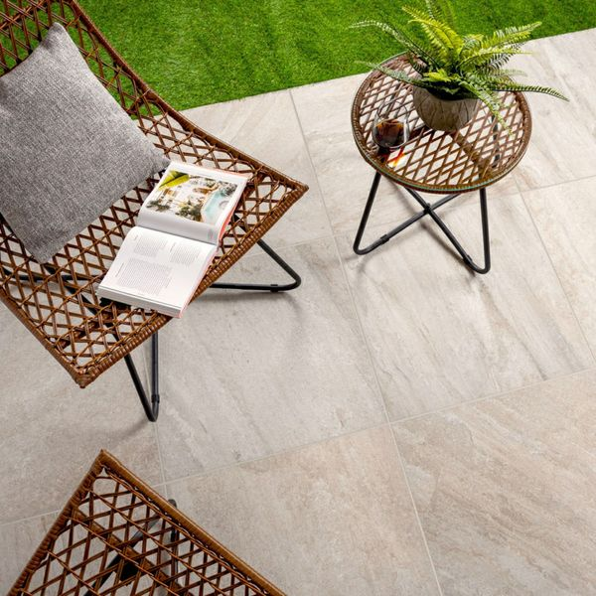**Icaria Plus Beige Porcelain Paving Slabs:**

## **Product Description**

High time your garden had a stylish new makeover? For a functional and durable patio base, look no further than these gorgeous Icaria Plus Beige 59x59 20mm Tiles. Made from 20mm thick porcelain, these tiles have a quartzite effect design with directional veining, which adds a characterful textural appearance.

**What's special about these tiles?**

> Quartzite stone effect design

> 20mm thick durable porcelain

> Perfect for a stylish naturalistic patio space

> R11 anti-slip surface

> Long lasting and frostproof

**The perfect finishing touch**

For that perfect finish around your patio space, line the edges with our stylish new [20mm Paving Slab Trims!](https://www.wallsandfloors.co.uk/20mm-paving-slab-trims) Choose the colour that best matches your style!

**Spring Savers product**

This is one of our Spring Savers products! Our Spring Savers products represent fantastic everyday low value and are already discounted to our lowest possible price - therefore, discount codes can not be applied to Spring Savers products.

## **Product INFO**

* Product ID: 44088
* Tiles Per SQM: 2.8246592754749
* Sale by: Per SQM
* Size: 595x595x20mm
* Weight: 13.55 KG
* Material Type: Porcelain
* Finish: Matt
* Colour: Beige/Ivory
* Suitability: Floors
* Area Of Usage: External
* Grade: 4
* Rectified Edge: Yes
* Underfloor Heating: Yes
* Anti Slip Grade: R11 / 12 Degrees
* Document: [20mm Installation Guide](https://m2.wallsandfloors.co.uk/media/amasty/amfile/attach/20mm-installation-guide_4.pdf),[Cleaning and Protection Guide](https://m2.wallsandfloors.co.uk/media/amasty/amfile/attach/ltp_-_walls_floors_-_external_porcelain_-_cleaning_and_protection_guide_-_april_2020.pdf)
* Thickness (mm): 20